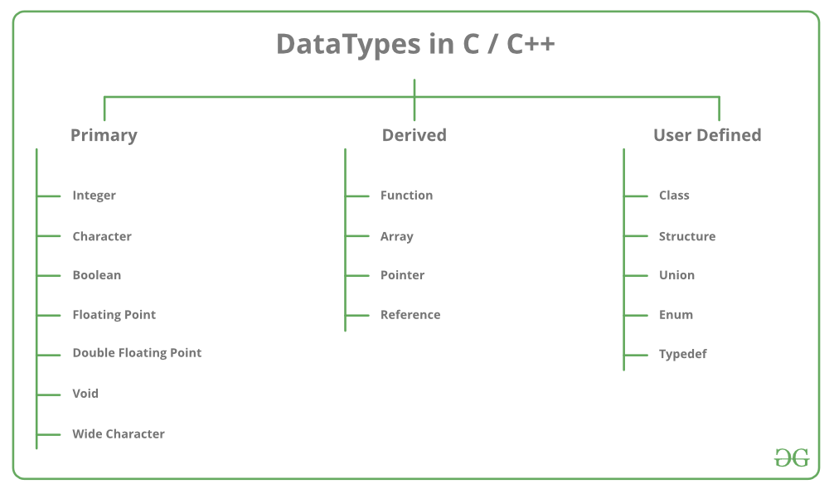

* **Integer**: The keyword used for integer data types is **int**. Integers typically require 4 bytes of memory space and range from -2147483648 to 2147483647.
* **Character**: Character data type is used for storing characters. The keyword used for the character data type is **char**. Characters typically require 1 byte of memory space and range from -128 to 127 or 0 to 255.
* **Boolean**: Boolean data type is used for storing Boolean or logical values. A Boolean variable can store either *true* or *false*. The keyword used for the Boolean data type is **bool**.
* **Floating Point**: Floating Point data type is used for storing single-precision floating-point values or decimal values. The keyword used for the floating-point data type is **float**. Float variables typically require 4 bytes of memory space.
* **Double Floating Point**: Double Floating Point data type is used for storing double-precision floating-point values or decimal values. The keyword used for the double floating-point data type is **double**. Double variables typically require 8 bytes of memory space.
* **void**: Void means without any value. void data type represents a valueless entity. A void data type is used for those function which does not return a value.
* [**Wide Character**](https://www.geeksforgeeks.org/wide-char-and-library-functions-in-c/): Wide character data type is also a character data type but this data type has a size greater than the normal 8-bit datatype. Represented by **wchar_t**. It is generally 2 or 4 bytes long.

| Data Type | Meaning | Size (in Bytes) |
| --- | --- | --- |
| int | Integer | 2 or 4 |
| float | Floating-point | 4 |
| double | Double Floating-point | 8 |
| char | Character | 1 |
| wchar_t | Wide Character | 2 |
| bool | Boolean | 1 |
| void | Empty | 0 |

## C++ Identifiers

All C++ variables must be identified with unique names.

These unique names are called identifiers.

Identifiers can be short names (like x and y) or more descriptive names (age, sum, totalVolume).

The general rules for naming variables are:

* Names can contain letters, digits and underscores
* Names must begin with a letter or an underscore (_)
* Names are case sensitive (myVar and myvar are different variables)
* Names cannot contain whitespaces or special characters like !, #, %, etc.
* Reserved words (like C++ keywords, such as int) cannot be used as names